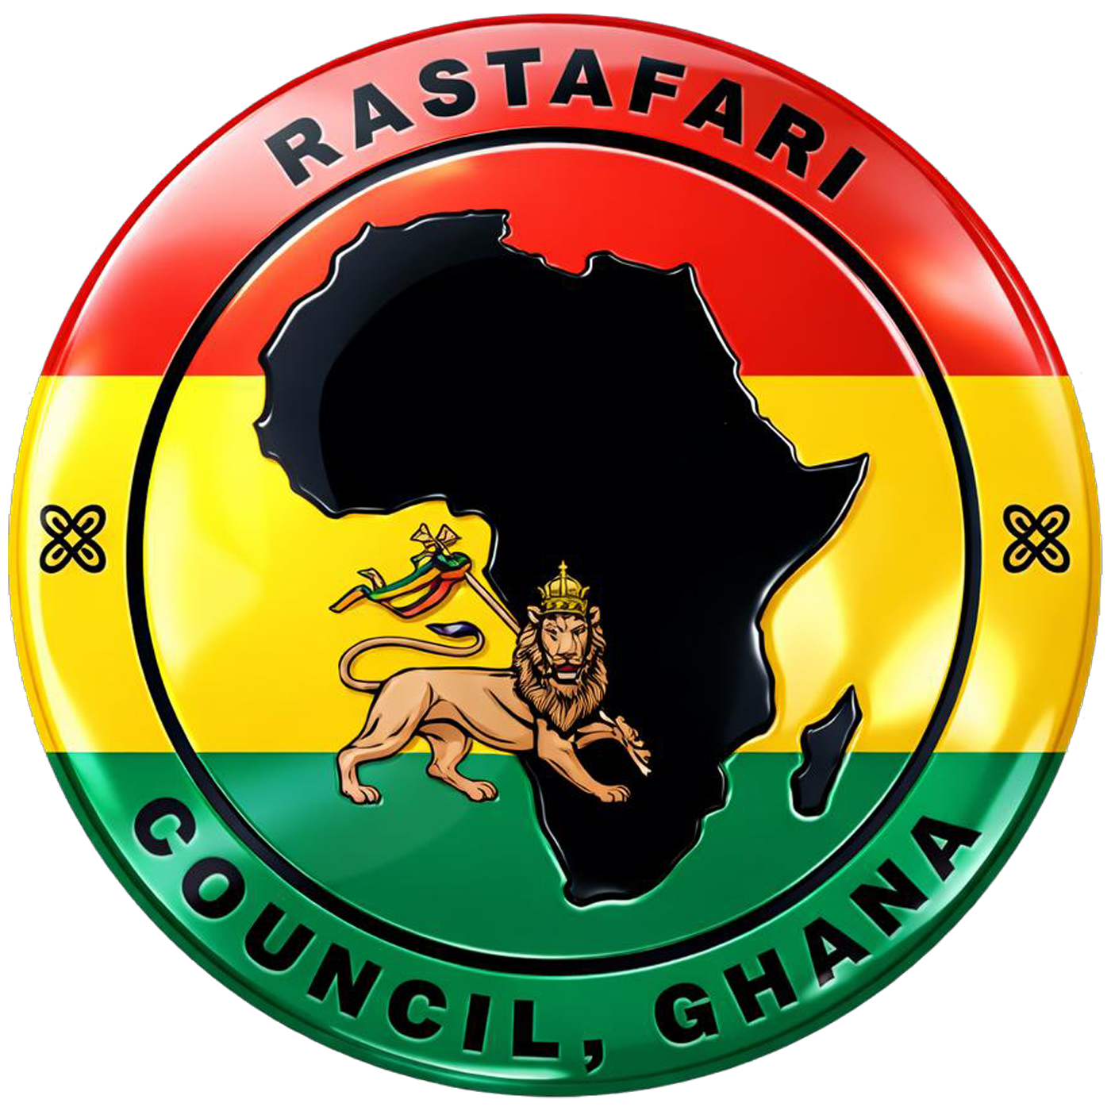

Rastafari Council, Ghana
Musicians Union of Ghana (Former GNTC)
Off Prof J.E. Atta Mills High St, Accra
+233 24 338 2474 | +233 24 403934
president@rastafaricouncilghana.com
_______________________________________________

The Rastafari Council of Ghana strongly condemns the continued assaults and hostility directed at immigrants in South Africa. Equally, we strongly condemn similar attitudes expressed in Ghana toward Nigerians, Nigeriens, and other Africans, as well as in all African countries where fellow Africans are treated as outsiders allegedly predisposed to corrupting the social or economic fabric of host nations.

Such hostile eruptions seem inevitable in colonially-derived economic systems that create financial desperation among populations. That is why in denouncing the anti-immigrant sentiments and actions wherever they occur, including Ghana, we expect similar official statements from the formidable South African Rastafari community - the largest on the continent to help re-orient public sentiment.

The anti-immigrant tendencies mirror the wider global resurgence of sentiments rooted in colonial notions of nationhood, citizenship, and identity. The antagonisms are driven by undue anxieties inherent in scarcity economics, micro-nationalism, and the failure to reject the inherited colonial framework that continues to shape political and social consciousness across the world.

The accusations leveled against visitors can just as easily be directed at citizens themselves. Besides, cracking down on undocumented immigration has never improved any country’s socio-economy. In reality, visitors are among the primary forces that dynamically enrich societies culturally, intellectually, and economically. African mobility and exchange have historically strengthened the continent, not weakened it.

We further condemn those who identify as Africanists yet attempt to justify these colonially-conditioned affronts to the dignity of fellow Africans conducted in the name of narrow patriotism.

At the same time, we commend the many people in host countries who have courageously rejected these divisive attitudes and defended the dignity and humanity of fellow Africans. We also salute Ghana’s Foreign Minister’s intervention and acknowledge the respective governments that have publicly condemned such fracturing tendencies.

Given the urgency of the matter, with lives and livelihoods at risk, we support all measures taken by the state to correct this error of judgment - yet we cannot wait on governments to solve this problem. Organizations and individuals committed to African unity must urgently intensify educational initiatives aimed at addressing the divisive misconceptions and ideological foundations that enable these tragedies. This should include the formation of emergency coalitions dedicated to consistently promoting Pan-African solidarity, historical consciousness, continental unity and the invention of a more meaningful economic system in Africa.

Once again, we affirm that visitors enrich countries, and African unity remains indispensable to the dignity, progress, and future of the continent.

Rastafari Council of Ghana

